**Google Translator**

[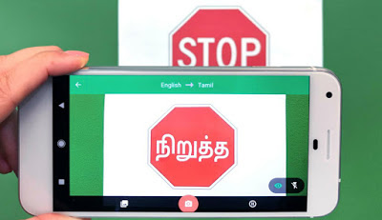](https://4.bp.blogspot.com/-DnkIQ_1Yzyk/W8qpkKRG6kI/AAAAAAAAAT8/KH6yfU6j_as2OPEoJ039vYvNkZTDZuIJwCLcBGAs/s1600/google1.jpg)

[Google translator](https://translate.google.com/) is one of the best platform for translating any language to another. In the translator there are more than **100 languages**. They serve **500 million** people daily throughout the world. They also has this **visual translating** feature. That means, you can take a photo with google translator app then ask the translator to translate it. Newly they added some extra languages on this numerous camera mode. Below, you will find everything in this respect.

[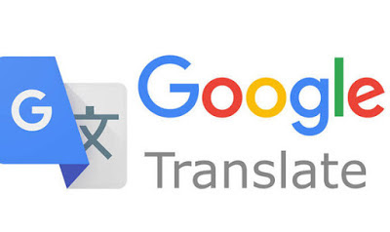](https://1.bp.blogspot.com/-1_kO1pLtOWc/W8qp6HnWaJI/AAAAAAAAAUI/kCaAWPefxOcdjq72m8uVSYTNysG_g6ZxwCLcBGAs/s1600/Google-translate-How-to-use-Google-translate-How-do-you-translate-websites-into-English-1009511.jpg)

The Camera Mode on Google Translate has been modernized with the ability to distinguish as many as **13 fresh languages**. The new addition carries some of the widespread vocal languages worldwide, counting Bengali. It enhances **13 additional Languages** to camera feature as many as, **nine Indian** languages that are currently added to the camera app feature of the Google Translate app are:

* Bengali
* Hindi
* Telugu
* Kannada
* Malayalam
* Tamil
* Punjabi
* Urdu
* Gujarati
* Marathi

Similarly, in today’s Google Translate update, there are additional languages added to the camera feature. These are **Thai, Vietnamese, and Arabic.**

[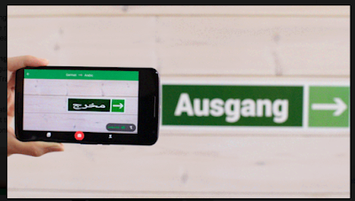](https://3.bp.blogspot.com/-ikVIgV2DqbM/W8qqNyymb2I/AAAAAAAAAUQ/ioj8d__om_AFFu9SZvBojzwSDygMN6VYwCLcBGAs/s1600/Screenshot-2015-10-15-08.24.23.png)

**How To Use**

You could take images of English text in the Google Translate app and translate the script to any of these languages. **Offline translations** allows operators to translate a word or sentence on Google Translate app deprived of linking to the Internet. To create use of this feature, users will have to  download linguistic packs for individually the languages they need to translate in the app while they are linked to the Internet.

[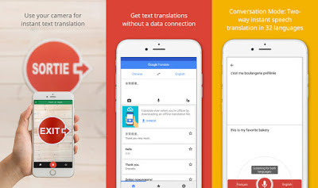](https://1.bp.blogspot.com/-cDEW91CTN3E/W8qqcw-8HYI/AAAAAAAAAUU/YGKJW3_NmGwjXudRZECCag8zCnILgCdVACLcBGAs/s1600/google-translate.jpg)

The feature is allowed in Google Translate’s newest update which is considered to build number 5.18.0.RC03. in order to increase access to this feature, operators will need to download the newest update, connect to WiFi and select the language they want to be translated offline. Offline transformation is pretty self-explanatory; it lets you download a file of approximately **30MB** in size to translate even  you don't have a data connection. Immediate camera translation is an extension of that, though it is worth noting that it'll merely work from English in offline mode.

[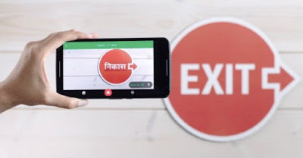](https://2.bp.blogspot.com/-2vNreyWyKWw/W8qqq_JQ96I/AAAAAAAAAUc/wuNe7uzYxoIiuU_6Dl4I1lpDW2e7zZJIACLcBGAs/s1600/Official_Google_Blog__See_the_world_in_your_language_with_Google_Translate.jpg)

The addition of 13 different languages joins the **26 remaining languages** on the Camera Mode of Google Translate. The facility also offers an instant camera translation choice for some of the most spoken languages. Back in **2014**, Google notably acquired San Francisco, California-based Quest Visual, the corporation that was behind the prominent augmented reality translation app Word Lens, to add photographic translation support to Google Translate.